**Biological Systems Presentation**

Name:________________________________________

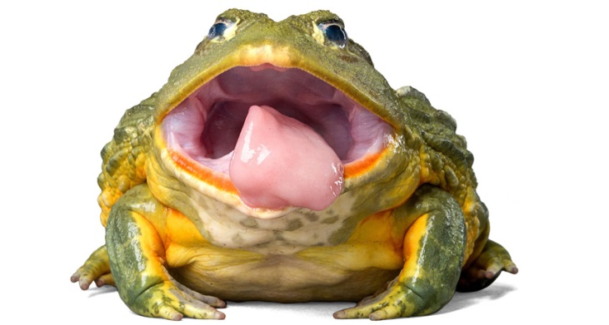Task: In small groups, you are to compare and contrast how body systems work in humans compared to other living organisms (plant or animal).

Choose **two** of the following body systems to focus on:

* Circulatory system
* Respiratory system
* Reproductive system

Research the similarities and differences between these two systems in different organisms of your choice, and compare these to what you have learnt in class about the human body systems. **Include the following key points**:

* Organs which make up the systems
* The effectiveness and reliability of these differences in helping the organism to survive and/or reproduce
* Compare the efficiency of other organisms’ body systems to that of the human body

You must prepare a **PowerPoint presentation and speech** to deliver to the class. Your presentation must be NO MORE THAN 5 MINUTES in length. It should be engaging, informative and easy to understand. It should be a maximum of 6 slides, not including the cover slide.

You will be marked on both the content and quality of your presentation.

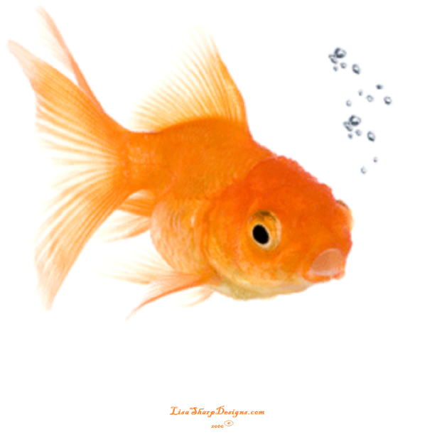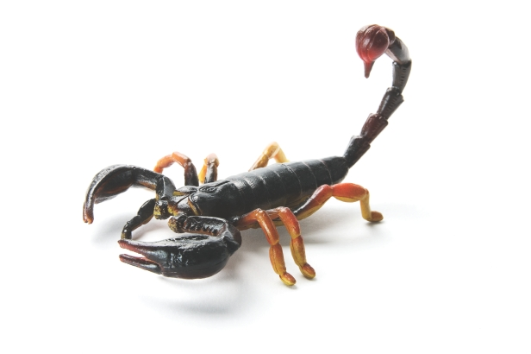

**Biological Systems Presentation**

**MARKING KEY**

|  |  |  |
| --- | --- | --- |
| **CONTENT** | Possible marks | Your mark |
| States similarities between systems in different organisms | 2 per system(Max. of 4) |  |
| States differences between systems in different organisms | 2 per system(Max. of 4) |  |
| Compares the efficiency of the systems between different organisms | 4 |  |
| Uses diagrams/ photos to support explanation | 3 |  |
| **PRESENTATION** |  |  |
| Correct spelling and grammar | 1 |  |
| Clear, easy to read font | 1 |  |
| Minimal text (no large paragraphs) | 1 |  |
| Uses simple language (in own words) | 1 |  |
| Adhered to 5 minute time limit | 1 |  |
| Visually engaging presentation | 1 |  |
| **ORACY** |  |  |
| Spoke clearly | 1 |  |
| Good pace, easy to follow | 1 |  |
| Words **supported** slides, did not read directly off slides | 1 |  |
| Good eye contact and gestures | 1 |  |
|  | **25** |  |